English | Maths | Science | Computing
How to Train Your Dragon:  Immersion in the book  Overcoming a monster story  Instructions  Kennings Poetry | Number and place value  Addition and Subtraction  Multiplication and Division  Fractions | Term 1: Forces  Term 2: Space | Systems and Networks  Creating Media  Online safety.
History | How to Train Your Dragon & The Vikings/Anglo Saxons  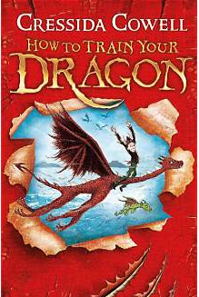 |  | Geography
Anglo Saxon settlement and struggles |  |  | Anglo Saxon and Viking Britain compared to modern day
PE | Art / Technology | Music | RE
Term 1  Netball and Gymnastics  Term 2  Swimming and circuits | Viking and Anglo Saxon houses  . | Shaping Music and Unlocking Vocal potential | What does it mean if Christians believe God is holy and loving?  What does it mean to be a Muslim in Britain today?
PSHE |  | MFL
Jigsaw: Being me in my world and Celebrating differences |  | French:  Term 1: Goldilocks Term 2: My Family

