ENGLISH | MATHEMATICS |  |  | SCIENCE |  |  | COMPUTING
Fiction: “The Queens Hat” by Steve Antony – losing tale  Reading: “Prince Cinders” by Babette Cole |  |  |  | Animals including Humans  Children will continue to learn about the classification groups for animals: mammals, fish, birds, reptiles and amphibians. They will learn about the different diets animals eat. Children will learn about the parts of the human body and the five senses. |  |  | Programming  We will look at some simple on-screen programing using ScratchJr.
  Position and Direction
  Place value within 100
  Money
  Time
HISTORY |  | Kings and Queens  In this topic in Term 6 we will be finding out about Kings and Queens. We will look at the Kings and Queens through the ages as well as looking into the life of Queen Elizabeth II and our current Monarch, King Charles.  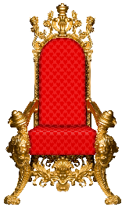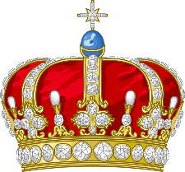 |  |  |  | GEOGRAPHY
To find out about the Kings and Queens of our past including Queen Elizabeth I and Queen Victoria, as well as looking at the life of Queen Elizabeth II and our new Monarch King Charles. We will compare the present day monarch with monarchs of the past. |  |  |  |  |  | Research famous destinations in our capital city London. Plot the route the ‘Queens Hat’ made through London on a map. If you were to recreate the journey, how would you travel to each location? How long might each step take?
PHYSICAL EDUCATION | DT |  | MUSIC |  | PSHE/ Jigsaw |  |  | RE
Cricket  Children will learn how to become a bowler, a striker, a catcher and a scorer as we start to learn about the sport of cricket.  Athletics  Children will develop the fundamental elements associated with athletics - running, jumping and throwing, in preparation for our Sports Day. | To design and make our own royal puppet. |  | Charanga – ‘Reflect, rewind and replay’  We will listen and appraise a range of classical music.  The National Anthem |  | Changing Me  We will begin to understand that changes happen as we grow and that growing up is natural. We will look at ways to cope with changes and how to learn new things. |  |  | Stories – Christianity  What makes some stories so important to different people?  We will discuss what stories are special to you and what makes them special.  We will look at why stories are important to some religious people and why.

