Watlington Primary School Home Learning Grid Reception Term 5 PEOPLE WHO HELP US + MAGICAL KINGDOMS
During term 5 we have some visits planned, to continue our learning from term 4, when we welcomed Elsie’s mum (Amy), who is a dietician and the dental nurse (Amy ‘the tooth lady’). This term we are hoping to arrange for the Fire Engine to come to ( school – which always creates a huge buzz. These enrichment experiences will help us to think about ‘People Who Help Us’. We are hoping to also have a visit from a florist (Riley’s mum). Please contact me if you are interested in coming in to talk about your job.
Please ensure you complete……  daily reading (record in the yellow reading record). | 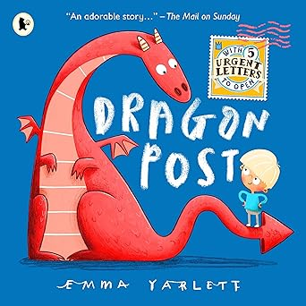  Read our Talk 4 Write book: Dragon Post  Bing Videos  Explore these other stories about dragons:  Daisy’s Dragons’ by Frances Stickley and Annabel Tempest  Dragons Love Underpants by Claire Freedman and Ben Cort  There is no Dragon in this Story by Lou Carter  The Dragon with the blazing bottom by Beach | Read a book about someone doing a job, here are some ideas:  ‘Mog and the Vee Ee Tee’ – Judith Kerr  ‘The Jolly Postman’ – J + A Ahlberg  ‘Going to the Doctor / Dentist’ Usbourne First Experiences  ‘Doctor Maisy’ by Lucy Cousins  The Fairytale Hairdresser and the Little Mermaid- Abie Longstaff  Give this a try – but be warned… the baby never once says please!!  The Elephant and the Bad Baby - Bing video | Tell us about jobs you know. What jobs can you talk about?  We are reading a book which features: a medic, a police officer, a fire fighter, a doctor, a refuse collector, a care worker and a teacher.  What other jobs do people do?  Draw a picture of someone doing their job and tell your friends about this.
 | Try writing your letter shapes neatly. Can you keep your letters on the lines?  Can you learn to read and spell some tricky words – I will get you started but you can pick any from your tricky word bookmark.  I / no / go / to / into / the / they / we / me / he / be / she / you / was. | Draw or paint or build a dragon at home.  What colour will your dragon be? What sort of skin does it have? Can it fly? Does it breathe fire? Where does it live/ How big is it? What sort of tale does it have? How does it behave… is it a friendly dragon? What does it eat? | What can you write now? How many words can you make using the letters in ….  MAGICAL KINGDOMS FAIRYTALE  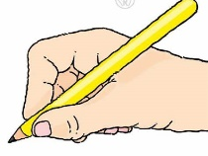  Grown-ups please check your child is working towards holding their pen / pencil in a comfortable grip. By the end of the year this is usually the pincer grip but is normal to not quite be there yet!
You could try some maths from here. There are some really quick and easy games to play, using simple everyday things you find at home.

Early Years Activities - Number (maths.org)
 | Can you be extra helpful at home?  Can you………. make your bed, wash up, dry up, empty the dishwasher, make your packed lunch, load the washing machine, help weed the garden, help with the shopping, un-pack the shopping write the shopping list, lay or clear the table….. what else could you do? | You could try creating a small world area at home, like this one. Or pick a theme that you are interested in, it could be a hairdressers, a hospital, a vets, a shop, a school, an office, a mechanics, a fairytale land…. The choice is yours!  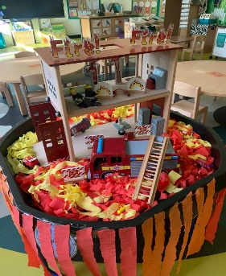  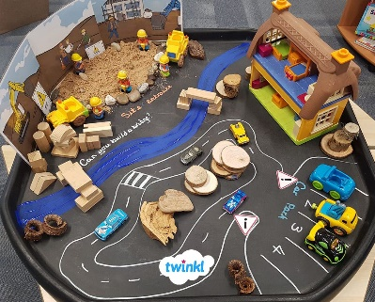  Can you make a café for your toys, or a shop?  Could you make a farm and be the farmer?  Can you make a garden centre outside?

