English | Maths | Science | Computing
Class read: Goodnight Mr Tom (historical settings)  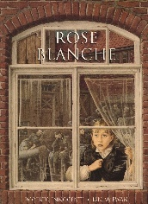  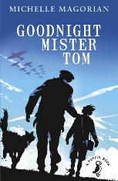  Narrative: Rose Blanche  Looking at suspense/warning narratives.  Non – Fiction: persuasion text  Poetry – War poems | Metric and imperial measures  Raito  Algebra  Decimals  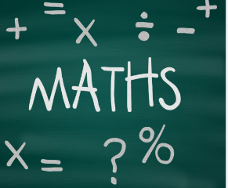  Fraction and Percentages  Area, perimeter and volume  Statistics | Term 3: Electricity  Understanding eclectic circuits and practical investigation. The focus of this activity is to explore how the loudness of a buzzer can be increased.. Develop skills in planning, investigating, and working safely with electrical equipment  Term 4: Light  Understanding how light travels. | Term 3  Programming A – Variables in games  This unit explores the concept of variables in programming through games in Scratch.  Term 4  Data and information - Introduction to Spreadsheets  This unit introduces the learners to spreadsheets. They will be supported in organising data into columns and rows to create their own data set.
History | WW2    Year 6 residential |  | Geography
World War Two: causes, key people and significant events. Evacuation and the impact of war (rationing) |  |  | Research on Allies / Axis countries
PE | Art / Technology | Music | PSHCE
  Circuit Training  Dance  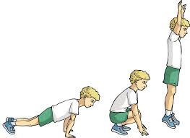 | Art: Drawing – Henry Moore  Propaganda posters  Blitz art  DT: Build an Air Raid Shelter/Cooking | Ukulele | Term 3 – Dreams and goals  Term 4 – Healthy Me
RE |  | MFL
Why do Hindus want to be good?  Learning about the Hindu worldview and way of life with particular progression from the units on ‘What do Hindus believe God is like?’ and ‘What does it mean to be a Hindu in Britain today?’ |  | French En Ville - Around Town  Pupils will learn the nouns and definite articles/determiners for 10 places around a town in the foreign language. They will learn how to navigate around the town using directions and prepositions to indicate the exact position of a place in relation to another in the foreign language

