Watlington Primary School Home Learning Grid Reception Term 3 Owls and Owlets
During term 3 we would like you to focus your home learning on developing your reading, speaking / listening and maths skills. If you would like some ideas of how to practise new found skills at home, have a look below.

As well as choosing an activity from here, please ensure you complete……  daily reading (record in the yellow reading record). | Draw your favourite British bird or owl. The basic shape for an owl is usually the same, as is a basic bird shape. Can you learn to draw one?  How-to-Draw-an-Owl-for-Kids-Step-by-Step.jpg (850×1000)  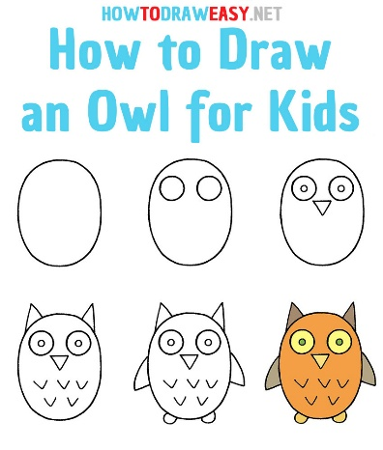 | You could try out some easy owl crafting at home. Here are a few ideas, using resources you can find easily at home, things you may already have or to use up some leftover junk or recycle some packaging.  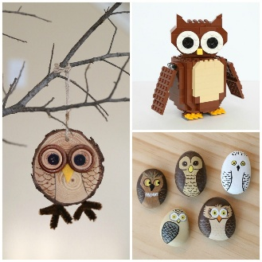  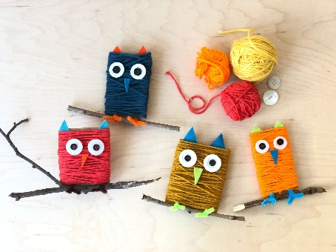  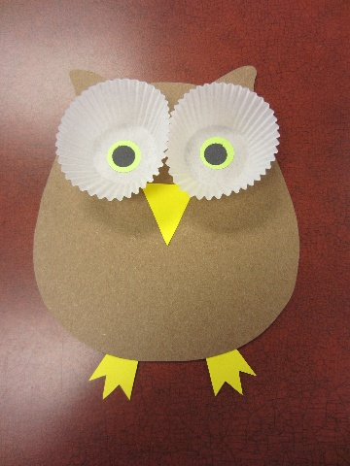 | Tell us about your favourite animal or bird. Is it a garden bird, or a more exotic bird? Does it live in this country? Can it fly? Do you know which birds fly and which don’t?  Maybe it lives in the UK but flies to another country during the winter.  Finish this sentence…..  My favourite bird is………  Then explain why.
Take a look at the Oxford Owl resources online for parents about teaching early maths concepts.

Maths at Home - Oxford Owl for Home

Maths: Age 4–5 (Reception) | Oxford Owl
 | Go on a nature walk and look for signs of owl habitats. The woods would be a great place to explore. Are there clues about where other animals might be found? Where do hedgehogs, owls, badgers and foxes live in the wild? What about squirrels, do they sleep in the ground like foxes and rabbits or in the trees, like owls?  Can you see any clues?  Count how many signs you spot on your walk. | Try listening to some of these lovely owl stories at home…. Enjoy!  Bing Videos – Owl Babies  Bing Videos – The Owl Who Was Afraid of the Dark  Bing Videos – The Wise Old Owl  Bing Videos – Wow Said the Owl

