ENGLISH | MATHEMATICS |  |  | SCIENCE |  |  | COMPUTING
Non-fiction:  - Non-chronological report (fact file) about London – children will be writing their own about Watlington  - Recount  Fiction in Reading lessons:  - The Boy Who Loved Maps by Kari Allen  - Martha Maps It Out by Leigh Hodgkinson |  |  |  | Scientist studies  We will study a range of scientists including Mae Jeminson |  |  | Online safety:  Learning about online safety.  Programming robots:  Accessing a range of learning-based games for Maths and English.  Using programmable Bee Bots and skills to enable them to find directions on a map.
  Number and place value- value of digits in HTO, more and less, using pictorial representations and objects.
  Addition and subtraction- number bonds to 20 including subtraction facts, solve one step problems, add and subtract one digit and two-digit numbers to 20
HISTORY |  | Watlington  In this topic we will be focussing on Geography and map skills whilst exploring our local town Watlington.  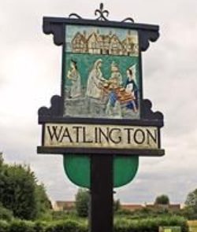 |  |  | GEOGRAPHY
We will briefly look at the history of Watlington, although this term we will primarily focus on the geography associated with the town. |  |  |  |  | To be able to use maps and globes to understand the world around them.  To link in compasses to direction and location.  To use geographical language and to describe the location and routes on a map.  To explore our school grounds and draw a simple map of the area.  To understand that the UK is an island.
PHYSICAL EDUCATION | ART |  | MUSIC | PSHE/ Jigsaw/Values |  | RE
Multi/Ball Skills: using a range of basic skills including throwing, catching, team games.  Gymnastics: learn basis moves and create a simple routine | Using and developing sketching and drawing skills to:  Draw simple maps.  Develop sketching techniques. |  | Use of simple percussion instruments to accompany songs.  Charango – In the Groove | Dreams and Goals - Aspirations, how to achieve goals and understanding the emotions that go with this |  | Important people in Christianity.

