Watlington Primary School Home Learning Grid Reception Term 1 The Three Billy Goats Gruff
During term 1 we would like you to focus your home learning on developing your reading, speaking / listening and maths skills.

As well as choosing one activity from this section please ensure you complete……  daily reading (record in the yellow reading record). | Look for an online story of The Three Billy Goats Gruff ….. or if you have a copy of the book at home read/ share that!  Bing Videos  Listen to the story and talk about this with someone at home.  Can you re-tell the story to a parent or another adult? Can you name the characters? Which one do you like best? | 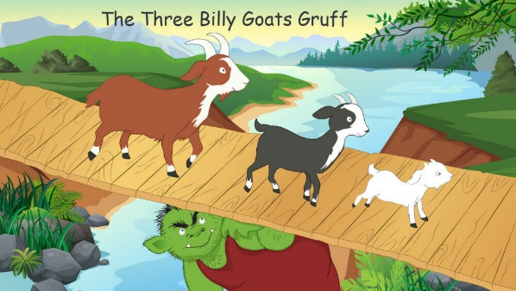 | Read another troll story, you could try:  The Troll by Julia Donaldson  Bing Videos  Did you like the book or not? Why?  Would you recommend them to a friend?  Who was your favourite character? Why?
 | Draw one of the following: a troll, the goats, a magical meadow, a troll’s cave  Talk to an adult about what you have drawn. | Practise saying the sounds in our phonics from your grid on the class page.  You could try putting them into a word.  You could find things at home starting with this letter sound. | Have a look at the Hedgehogs class page, with a grown up. Can you find some photos of your classroom, your friends and maybe you?
 | Practice writing numbers to 10 (and above ) correctly in numerals.  Can you learn to write the numbers round the right way and in the correct sequence?  Practise counting lots of different things at home…. Steps up your stairs, cups to lay the table, socks in the washing pile, apples in the fruit bowl, teddies on your bed…… the possibilities are endless! | Can you create a ‘touchy-feely’ collage of a troll from craft materials such as wool, fabric, pipe cleaners or cotton wool?  What will your troll look like? It is a make-believe character so it can be anything you want, any colour, any size or shape – use your imagination – go wild!! | Can you write your first name? Remember to use a capital letter for the start of your name.  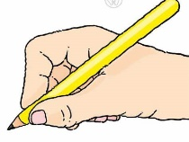  Grown-ups please check your child is working towards holding their pen / pencil in a comfortable grip. By the end of the year this is usually the pincer grip but is normal to not quite be there yet!
 | Find out some facts about real life goats or other farmyard animals. What do they need? How do farmers take care of their animals? What do they eat? Where do they sleep? How long do they live? | Visit a farm and find out more about some familiar animals | Draw a picture of your family and bring it in to show your teachers.  Can you write the names of other people in your family?

