Mele Kalikimaka

Jingle bells upon a steel guitar
Through the palms we see the same bright star

Mele Kalikimaka is the thing to say
On a bright Hawaiian Christmas day
That's the island greeting that we send to you
From the land where palm trees sway
Here we know that Christmas will be green and bright
The sun will shine by day and all the stars at night
Mele Kalikimaka is Hawaii's way
To say Merry Christmas to you
X2

Mele Kalikimaka is Hawaii's way
To say Merry Christmas
A very, very, Merry, Merry Christmas
To say Merry Christmas to you!

Name:

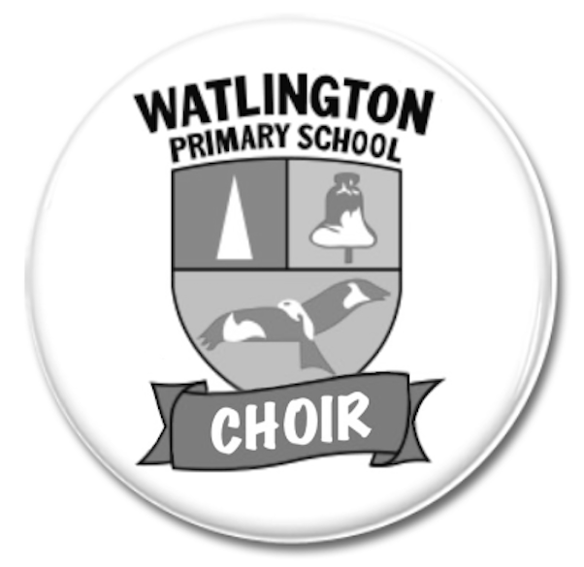

Christmas
Song Book
2024

Once in Royal David’s City

V1 - Soloists
Once in royal David’s city
Stood a lowly cattle shed
Where a mother laid her baby
In a manger for His bed:
Mary was that mother mild
Jesus Christ her little Child.

V2 - All
He came down to earth from heaven
Who is God and Lord of all,
And His shelter was a stable,
And His cradle was a stall;
With the poor, and mean, and lowly,
Lived on earth our Saviour holy.

V3
And through all His wondrous childhood
He would honour and obey,
Love and watch the lowly maiden,
In whose gentle arms He lay:
Christian children all must be
Mild, obedient, good as He.

V4
And our eyes at last shall see Him,
Through His own redeeming love;
For that Child so dear and gentle
Is our Lord in heaven above,
And He leads His children on
To the place where He is gone

Silent Night

Silent night, holy night,
All is calm, all is bright
Round yon virgin mother and child.
Holy infant, so tender and mild,
Sleep in heavenly peace,
Sleep in heavenly peace.
Silent night, holy night,
Shepherds quake at the sight;
Glories stream from heaven afar,
Heavenly hosts sing Alleluia!
Christ the Saviour is born,
Christ the Saviour is born!
Silent night, holy night,
Son of God, love's pure light;
Radiant beams from thy holy face
With the dawn of redeeming grace,
Jesus, Lord, at thy birth,
Jesus, Lord, at thy birth.

When I Followed the Star

V1
Out on the hills o’er Bethlehem keeping my sheep one night,
Angels appear from on high appeared, sky was filled with light.

V2
Gabriel said, “A king is born, God’s long-awaited son,
Hurry now, go to the child, see what our Lord has done”:

Chorus Tiny Saviour lying in straw, King of the world you are.
I found out what heaven was when I followed, followed the star.

V3
Wise men bring their gold and myrrh, but, poor as I am,
All I have to offer him is a humble lamb:

Chorus Tiny Saviour lying in straw, King of the world you are.
I found out what heaven was when I followed, followed the star.

V4
Do not wait to worship him, sing for joy today,
Jesus reigns in love supreme, now and always.

Chorus Tiny Saviour lying in straw, King of the world you are.
I found out what heaven was when I followed,
Followed the star (follow, follow, follow the star),
Followed the star (follow, follow, follow the star),
Followed the star (follow, follow, follow the star),
Followed the star.

Bottom of Form

Cool Yule

From Coney Island to the Sunset Strip,
Somebody's gonna make a happy trip tonight
When the moon is bright.

He's gonna have a bag of crazy toys
To give the grown-ups and the girls and boys, so dig,
Santa comes on big.

He'll come a-callin' when the snow's the most,
When all you cats are sleepin' warm as toast,
And you’re gonna flip when Old Saint Nick
Plays a lick on a peppermint stick.

He'll come a-flyin' from a higher place
And fill the stockings by the fireplace,
So you'll have a yule that's cool.

16 bar dance break

He’ll come a-callin' when the snow's the most,
When all you cats are sleepin' warm as toast,
And you’re gonna flip when Old Saint Nick
Plays a lick on a peppermint stick.

He'll come a-flyin' from a higher place
And fill the stockings by the fireplace,
So you'll have a yule that's cool, cool, cool yule,
You’ll have a yule that is cool!

Père Noël

Père Noël is the French Father Christmas,
Wearing a cloak trimmed with fur, white as snow.
Gui, his donkey whose name means mistletoe
Follows wherever he goes:

Chorus 1
Père Noël, Père Noël, Père Noël, Père Noël,
J’ai été bon toute l’année;
Père Noël, Père Noël, Père Noël, Père Noël,
Apporte-moi des cadeaux
Cher Père Noël, CHER, CHER,
S’il vous plaît.

Chorus 2
La la la la la la la,
La la la la la la la,
La la la la la la la,
La la la la la.

La la la la la la la,  La la la la la la la,  La la la la la la la,  La la la la la. | Dear Father Christmas  We’ve been good all year:  Please bring us presents and  Glad Christmas cheer.

Take your shoes off and leave them by the fireside,
Fill them with carrots and fill them with treats.
Gui lands silently on the rooftop,
Let’s give him something to eat.

Chorus 1 & 2
Repeat Chorus 2

Cher Père Noël, Père Noël
(shout) Père Noël!

Feliz Navidad

Feliz Navidad, Feliz navidad
Feliz navidad, prospero año y felicidad
Feliz Navidad, Feliz navidad
Feliz navidad, prospero año y felicidad
I wanna wish you a merry Christmas
I wanna wish you a merry Christmas
I wanna wish you a merry Christmas from the bottom of my heart
I wanna wish you a merry Christmas
I wanna wish you a merry Christmas
I wanna wish you a merry Christmas from the bottom of my heart
Feliz Navidad, Feliz navidad
Feliz navidad, prospero año y felicidad
Feliz Navidad, Feliz navidad
Feliz navidad, prospero año y felicidad
I wanna wish you a merry Christmas (Merry, Merry Christmas)
I wanna wish you a merry Christmas (Merry, Merry Christmas)
I wanna wish you a merry Christmas from the bottom of my heart
I wanna wish you a merry Christmas (Merry, Merry Christmas)
I wanna wish you a merry Christmas (Merry, Merry Christmas)
I wanna wish you a merry Christmas from the bottom of my heart
Feliz Navidad, Feliz navidad
Feliz navidad, prospero año y felicidad.

The Twelve Days of Christmas
On the first day of Christmas
My true love gave to me
A partridge in a pear tree.
On the second day of Christmas
My true love gave to me
Two turtle doves
And a partridge in a pear tree
On the third day of Christmas
My true love gave to me
Three French hens…
On the fourth day of Christmas
My true love gave to me
Four calling birds…
On the fifth day of Christmas
My true love gave to me
Five gold rings…
On the sixth day of Christmas
My true love gave to me…
Six geese a-laying
On the seventh day of Christmas
My true love gave to me
Seven swans a-swimming…
On the eighth day of Christmas
My true love gave to me
Eight maids a-milking…
On the ninth day of Christmas
My true love gave to me
Nine ladies dancing…
On the tenth day of Christmas
My true love gave to me
Ten lords a-leaping…
On the eleventh day of Christmas
My true love gave to me
Eleven pipers piping…
On the twelfth day of Christmas
My true love gave to me
Twelve drummers drumming…

