Watlington Primary School Home Learning Grid Year 1 Term 2 ‘Toys – Past and Present’
Weekly | Reading: Daily Spellings: Weekly
 | Learning Opportunities
Reading   | Read some fiction books about toys.  What did you like or dislike about the story?  Can you write a book review to share with the class?  Can you predict a new ending?  Discuss the setting and characters.  Compare two stories about toys. What is the same/different? | Can you find a poem to read about toys? What makes it a poem and not a story or information text?  Can you perform the poem to your grown up? | Read a new genre of book.  Try a non-fiction book about the history of toys.  What did you like or dislike about it? What have you learnt? How do you know these facts are accurate? What is the best way to learn about history?
Phonics/  Writing  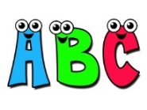 | Phonics/Spellings  Keep practising so you can remember your letters and digraphs quickly.  Have a go at learning to spell some of the tricky words stuck into your homework book. | Handwriting  Practise letter formation using the cursive handwriting sheet stuck into your homework book.  Now write a word or sentence about your favourite toy and/or your parents/grandparents favourite toy and still use the correct formation.  When you feel confident, try to join your writing using cursive.  Can you write a list of words to describe your favourite toy? Can you put this into a really interesting sentence? | Non-fiction writing  Can you research a toy from the past, draw a picture of it and then describe what it is made of and how you play with it?  Can you write some instructions on how to play a board game? Ask someone else to follow your instructions and play the game with them.  Can you write a poem about toys? Remember to use lots of adjectives too.
Maths  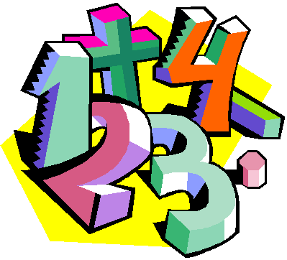 | Number facts  Practice counting to number 20, forwards and backwards. Can you count in 2s?  Can you write all the different ways you can make 10 with 2 numbers? Can you try this up to 20?  Can you do some simple addition and subtraction problems with numbers up to 10? | Maths  Can you draw a picture using 2D shapes? Can you label them.  Can you now make a model using 3D shapes? Do you know what these 3D shapes are called?  Can you make and run a toy shop using price tags and a till to serve your customers?  Can you play a game of dominos, making sure you count the dots correctly to match the dominos up. | Problem solving  If Emma has 3 dolls already and she receives 2 more for her birthday, how many does she have now?  Oh no, Emma loses 1 of these dolls. How many is she left with?  Can you think of your own maths problem, record it and ask a grown up or sibling to answer it for you!
Science  PSHE/Values | Materials  Can you go on a material hunt around your house? What are most objects made from? Why are certain objects made from a particular material? | Values  Our values in school are  Be Respectful  Be Responsible  Be Resilient  Discuss with a grown up what they mean to you.  How can you show these values at home and in school? | PSHE  We are all different and all unique, which is what makes us who we are. Can you write about why you are unique? What are your special gifts?
Topic: Toys | Art, Design and Make  Could you design and make your own finger or stick puppet? Perhaps you could then put on a puppet show to an audience.  Can you design a new toy – name it, draw it, label it and write instructions on how to play with it. | History  Can you research toys that your parents and grandparents played with? Do you have any photos of them playing with them? Are you able to bring an old toy in to share with the class, when it is your ‘Show and Tell’ slot? | Movement and Dance  Can you play a new game outside? Try skipping, quoits, bowls, croquet or hopscotch.

