ENGLISH | MATHEMATICS |  |  | SCIENCE |  |  | COMPUTING
Fiction: ‘The Fish who could Wish’  Poetry: ‘Commotion in the Ocean’ – poems about sea creatures  Reading: ‘The Storm Whale’ and ‘The Secret of Black Rock’ | Length and height (in cm)  Volume and mass  Multiplication and division  Fractions (1/2 and 1/4) |  |  | Animals including Humans  Children will learn about five of the groups that scientists use to classify animals: mammals, fish, birds, reptiles and amphibians. They will identify the group an animal belongs to by its features and will classify animals according to their group. They will learn about the different diets animals eat. Children will learn about the parts of the human body and the five senses. |  |  | Camera skills  Children will take their own pictures for a project using the camera on an iPad.  Digital writing  Children will begin to use an iPad to write text and create a digital story.
HISTORY |  | Under the Sea  In Term 5 our topic will be ‘Under the Sea’ where we will be learning about climate change and recycling, and how we can help our planet. We will be learning about the different seas and oceans  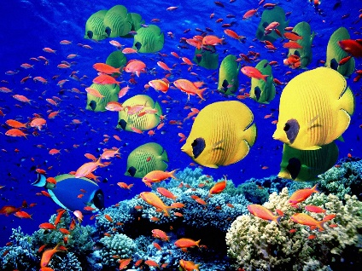 |  |  |  | GEOGRAPHY
We will look at how climate change has altered over the years and what we can do now to help the worlds future. |  |  |  |  |  | We will look at the different oceans in the world, explore habitats under the sea and research endangered animals, with a big focus on saving the planet and climate change.
PHYSICAL EDUCATION | Art |  | MUSIC |  | PSHE/ Jigsaw |  |  | RE
Tennis  Rounders | We will be making a structure of a sea creature from recyclable materials, as well as creating under the sea pictures/collages. |  | Charanga – ‘Your Imagination’  Children will listen and appraise songs based on using their imagination. |  | Relationships  In our Jigsaw lessons we will be understanding what makes a family, how to be a good friend and how to appreciate people who are special to us. |  |  | Groups – Christianity  We will look at how it feels being part of a group (religious and non-religious), and how this is important to Christians.

