Watlington Primary School Home learning Grid Year 1 Term 3 ‘Pirates’
Weekly | Reading: Daily
 | Learning Opportunities
Reading   | Read some books about pirates. Who are the characters?  Where is the book set?  What did you like or dislike about the story?  Can you write a book review to share with the class?  Can you predict a new ending?  Discuss the setting and characters.  Compare two stories about pirates. What is the same/different? | Look for punctuation in the stories you are reading.  If you see speech marks, how would the character speak?  Why is a word written in bold or italics?  How would you read a sentence with an exclamation mark at the end, or a question mark? Think about improving expression. | Read a new genre of book.  Try a non-fiction book, a set of instructions or a magazine.  What did you like or dislike about it?  Would you recommend it as a class read – why?
Phonics/  Writing   | Phonics/Spellings  Keep practising so you can remember your letters and digraphs quickly.  Have a go at learning to spell some of the tricky words stuck into your homework book. Here are some ideas to help you learn them.  1.Speedy Spellings! Read each word, then write them out as quickly as you can. You could time yourself, then try to beat your time!  2. Write the word using chalk or paint.  3. Make the word out of spaghetti.  4. Make your word colourful. | Handwriting  Practise letter formation using the cursive handwriting sheet stuck into your homework book.  Now write a word or sentence about Pirates and still use the correct formation  When you feel confident, try to join your writing using cursive.  . | Creative writing  Imagine you are a famous pirate. Create a post card to send home to your loved ones from this faraway place. On the front draw scenes of where you have visited. On the back write to friends telling them about your visit there - battles you have fought; prisoners you have captured or ships you have plundered.
Maths  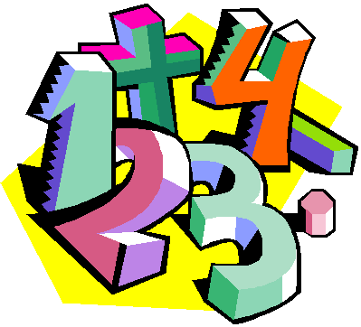 | Number facts  Practise forming your numbers correctly and the correct way round.  Practise counting in 2, 5s and 10s. Can you count forwards and backwards?  Number bonds: To know number bonds to 20.  E.g., 2+18=20 10+10=20  Can you practice your addition and subtraction within 20? | Maths Games  Can you play any board games at home where you need to count? Snakes and ladders is a good one. Or card games such as Uno. Can you recommend any other games to your class mates? | Problem solving  Use any method that you are confident with to help work out these problems.  -Pirate Pete has found 10 gold coins and needs to share them with 5 shipmates. How many do they each get?  -Pirate Paula had 9 jewels, but she looks in the treasure chest and she only has 6 left. How many does she need to find?  Can you think of your own maths problem, record it and ask a grown up or sibling to answer it for you!
Science  PSHE/Values | Inventors and Scientists  Pick an inventor or scientist that you are interested in and create a fact file about his/her life and what they did/made to become famous. | Values  Our values in school are  Be Respectful  Be Responsible  Be Resilient  Discuss with a grown up what they mean to you.  How can you show these values at home and in school? | PSHE - Jigsaw  Can you set yourself some goals for the New Year? How are you going to achieve these? What makes it a success?
Topic: Pirates | Design and make  Make a pirate ship out of anything you like. Junk modelling, Lego; but make sure it’s got an anchor, sail and crow’s nest! Take a picture of it as we would love to see what you have made. | Treasure Map  Make a treasure map showing the pirates where to dig for treasure. You could use coordinates (e.g. A-F along the bottom, 1-8 up the side) or NSEW compass directions. Have a go at writing some clues or directions to help locate the treasure. You could stain you map with used teabags to make it look old. | Art and Craft  Draw or paint a picture of the sea or an island. Think about the colours you use to try to show if the sea is calm or choppy.

