Dear Parents,

These books are in our book corner, they are our **‘Fabulous Favourites’** for Robins and Hedgehogs.

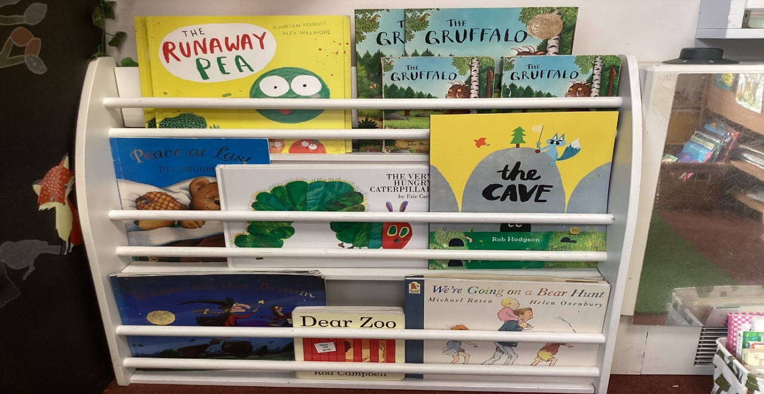

We read them to the children, so they become familiar with these stories. They are all chosen as the perfect ‘read aloud’ books, which give enjoyment each time they are shared. They all have a line or repeated refrain that can be learnt off by heart and spoken aloud, so children can join in with the adult.

So if you want to know why your child is chanting: Oh help, oh no….it’s a Gruffalo!” I hope that explains it!

For those of you who like to know the thinking and research behind our initiatives, here it is:

[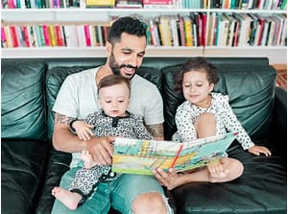](https://www.bing.com/images/search?q=data+facts+about+benefits+of+children+hearing+stories+read+aloud&id=40A6D043482E56858CA3D7A64C398F9F2918B755)

“Even the youngest children benefit from hearing their caregivers read to them. A 2013 study showed that babies who are read to and talked to **score higher in language skills and cognitive development**, like problem solving. Research from 2018 suggests that this link extends throughout childhood into the teen years. **“**

“Reading aloud to children has clear cognitive benefits. For example, [brain scans](http://pediatrics.aappublications.org/content/early/2015/08/05/peds.2015-0359?sid=5b1e0b71-9369-4d5e-923b-8a304e346b35) show that hearing stories strengthens the part of the brain associated with visual imagery, story comprehension, and word meaning. One [study](http://www.trelease-on-reading.com/read-aloud-brochure.pdf) found that nursery children who were read to at least three times a week had a “significantly greater phonemic awareness than did children who were read to less often.”