Little Donkey

Little donkey, little donkey  
On the dusty road  
Gotta keep on plodding onward  
With your precious load

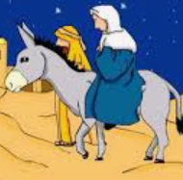

Been a long time little donkey  
Through the winters night  
Don't give up now little donkey  
Bethlehem's in sight

Ring out those bells tonight  
Bethlehem, Bethlehem  
Follow that little star tonight  
Bethlehem, Bethlehem x2