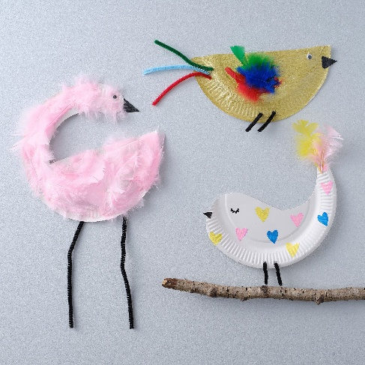**Watlington Primary School Home Learning Grid Reception Term 4 Pip and Egg**

|  |  |  |  |
| --- | --- | --- | --- |
| **During term 4 we would like you to focus your home learning on developing your reading, speaking / listening and maths skills.**  **YOU DO NOT NEED TO COMPLETE EVERY ACTIVITY.** | | | |
| **As well as choosing one activity from this section please ensure you complete……**  **daily reading (record in the yellow reading record).** | [Bing Videos](https://www.bing.com/videos/riverview/relatedvideo?&q=pip+and+egg+story&&mid=2DD420C8A5433345BB5B2DD420C8A5433345BB5B&&mcid=7B637FF74A2E4E84977067961F7BB3D3&FORM=VRDGAR)  Take a look at the story online, if you don’t have the book at home. Enjoy!  Try to watch at least once all the way through so you get to know the story well. | Our new book features two settings, a woodland /countryside setting and a city. Talk to your child about settings in stories – where does this story happen? How do we know? What clues are there in each book?  Can you draw or paint a picture of a place in the book? Which place do you like best?  Can you build a city from Lego or wooden bricks, like the one Egg visits? | Practise counting in 2’s….. how many pairs can you find at home to count in 2’s?  Can you count pairs of socks or gloves?  Can you line up cars or toys and count them in 2’s? |
| **Research**  Our topic focuses on life cycles of birds, plants and trees. What can you find out about different life cycles? Can you do some research about different creatures than lay eggs… we know it isn’t just birds. | Practise saying the sounds in our phonics from your grid on the class page.  You could try putting them into a word.  You could find things at home starting with this letter sound. | See the source imageGrown-ups please check your child is working towards holding their pen / pencil in a comfortable grip. By the end of the year this is usually the pincer grip. |
| Please remember to look at the books we post online each week.  Student Home |
| **Growing**  You could try growing a plant.  Can you plant a seed and watch it grow?  How will you help it to grow super-fast? | krokotak | birdYou could try making a paper plate bird, or a chick in a nest. | |