Advertising  Write a persuasive advert (magazine, poster, TV or radio) encouraging someone to change a habit in order to help the planet. Which habit will you choose? You could encourage people to recycle, walk more or conserve water (or anything else you would like). |  | Art  Create a piece of art inspired by climate change. You can use any materials or style that you like.  Write a brief explanation to go with your work. |  |  | Climate Change board game  Design and create your own ‘Climate Change’ board game.  Think about positive changes people can make to move forward on the game, (e.g. recycling, turning off lights) and negative choices that result in moving backwards/missing a turn. Maybe you could include question cards about climate change?
Review  Using NASA's earth-observing satellites, we can watch how some of our most influential climate indicators have changed over the years. Observe the progression in sea-level rise, carbon dioxide emissions, and global temperature fluctuations  Climate Time Machine (nasa.gov)  Can you write a summary of what you discovered from this website? |  |  | 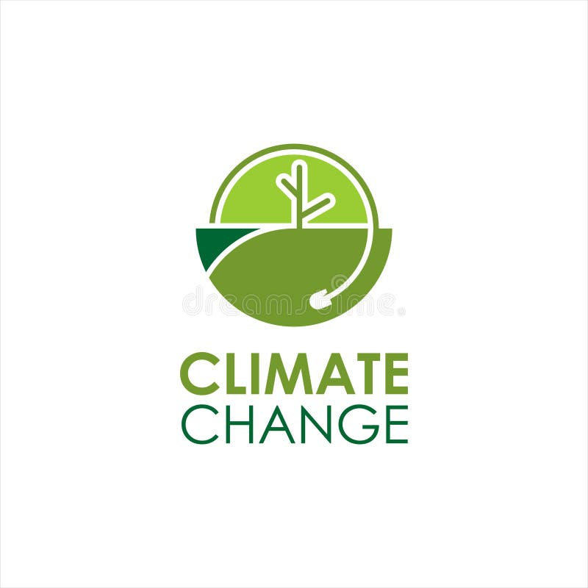 | Junk modelling  Create a junk model with left-over packaging. This gives it a new use, rather than putting it straight in the bin. Here’s steps how to make a bird feeder from a plastic bottle:  Make a Recycled Bird Feeder | Fun Activities for Kids - The RSPB  Other ideas:  Upcycling Craft Ideas | Lolly Stick & Toilet Roll Crafts - The RSPB
Cooking  Design and/or make a recipe using leftovers to minimise food waste.  Some possible ideas:  How to use up leftovers | BBC Good Food | Clothing  Design some clothing made from recycled materials. Draw your designs and label them. Alternatively, you could even make the clothing if you have the materials.  Write a brief explanation about your design. |  |  |  |  | Animals  Create an information leaflet or non-chronological report about an endangered animal of your choice.  Endangered Animal Facts For Kids | DK Find Out  Endangered Animals of the World - Endangered Animals | Young People's Trust For the Environment (ypte.org.uk)

