English | Maths | Science | Computing
Text – ‘Oh Maya Gods’ by Maz Evans  Reading – Vocabulary, inference, prediction, explain and summarise.  Writing extended answers using the structure: Point, Explain and Expand.  Spelling, Punctuation and Grammar  Perfect and progressive tenses.  Recap of all grammatical terminology and punctuation rules in preparation for SATs. | Algebra  Use simple formulae and generate linear number sequences.  Express missing number problems algebraically.  Find pairs of numbers that satisfy an equation with 2 unknowns.  SATs Revision  Recap of all key mathematic methods and facts in preparation for SATs. | Electricity  Associate the brightness of a lamp or the volume of a buzzer with the number and voltage of cells used.  Compare and give reasons for variations in how components function, including the brightness of bulbs, the loudness of buzzers and the on/off position of switches.  Use recognised symbols when representing a simple circuit. | Use search technologies effectively, appreciate how results are selected and ranked.  Use technology safely, respectfully and responsibly.  Understand computer networks including the internet; how they can provide multiple services, such as the world wide web; and the opportunities they offer for communication and collaboration.
History | 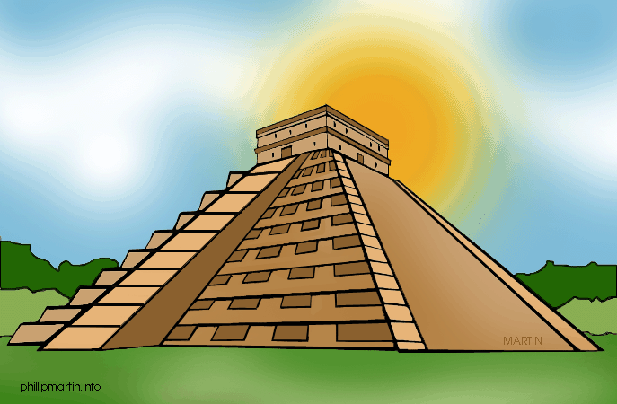  The Maya Civilisation |  | Geography
Maya civilisation  Understand the timeline and chronology of the Maya civilisation.  Explore their traditions and culture.  Evaluate the impact of their inventions and developments.  Evaluate primary and secondary sources. |  |  | Maya civilisation  Identify and locate continents and key countries in the world.  Understand the location of the Maya civilisation.  Identify physical and human features of Mexico and Central America.
PE | Art / Technology | Music | PSHCE
Tennis  Serving and technique  Footwork  Cricket/Rounders  Fielding, batting and bowling techniques | Mayan masks  Mayan Artefacts  Bonampak Murals  Mayan Temples  Ceramics and clay | Ukulele  Play musical instruments with increasing accuracy, fluency, control and expression.  Use and understand staff and other musical notations. | Jigsaw term 5  Relationships – building healthy positive relationships
RE  Freedom and justice – what this means to different religions. |  | French  ‘My home’ and ‘The Olympics’

